Ian Kilgore

10/24/2017

Interpreting a Glacial Landscape

Materials:

* Earth science textbook
* Topographic map
* pencil

Introduction:

The purpose of this experiment is to learn to interpret landscapes. Using a topographic map we can identify glacial features on a map by looking at lines of elevation and the location of lakes and other features to reconstruct geologic history.

Procedures:

1. Using the topographic map provided determine what elevations are between Sugar Loaf Mountain and Bear Lake using every fifth contour line for the data points.
2. Using the graph provided plot these elevations along the y-axis of the grid.

Data table:

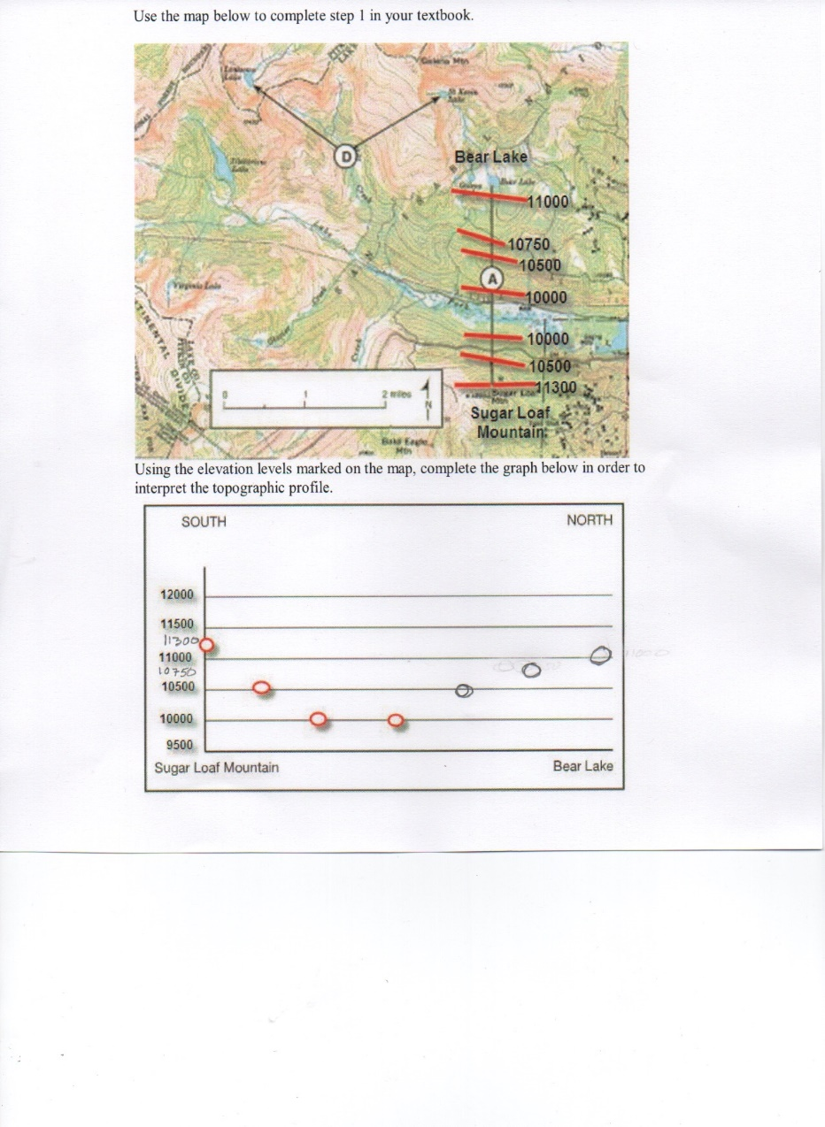

Conclusions:

I can tell that the valley formed between Bear Lake and Sugar Loaf Mountain was formed by a glacier because of its U-shaped valley. I can tell that it was formed by a glacier and not a continental ice sheet because the surrounding land around an ice sheet is not much higher in elevation than the sheet itself. The terrain around this valley varies greatly in elevation indicating a glacier formed it. The glacier moved from west to east and you can tell because of the big lake at the base of the glacier that was formed after it was melted. Letter D points to two cirques. The tarns inside the cirques are named St. Kevin Lake and Lonesome Lake. Letter B points to the hanging valleys and letter C points to the arêtes. Homestake Peak is a horn. The glacial till in feature E was deposited as the glacier melted and dropped all its rocks in one place. This till will be a mixture of all different sized particles. Turquoise Lake formed as the melting glacier ice filled in a large depression left by the glacier.